CS 4442 Artificial Intelligence II - Assignment 2

Ian Wood - 250690592

March 15th 2017

# Question 1:

b)

The filter given in this problem has two noticeable effects. The first is that most of the uninteresting areas in the image have been converted to have an intensity of ~128 or half of the maximum intensity for a given pixel. The interesting areas of the image are either more intense or less intense than the middle intensity.

In effect, this filter provides edge detection while dulling out the rest of the image.

# Question 2:

b)

Before stretch: 4.5304e+06

After stretch: 9.1853e+05

# Question 3:

b)

Before stretch: -58999407

After stretch: 1.5542e+07

j)

total cost of seams for catResized.png: -1.0109e+06

total cost of seams for faceResized.png: -4.0257e+05

Example 1:

Image used: face.jpg

W = [1 1 1]

v = -80

h = 0

result:

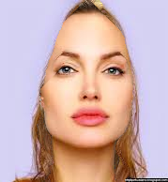

Example 2:

Image used: face.jpg

W = [0 0 -100]

v = -100

h = 0

result:

